section B
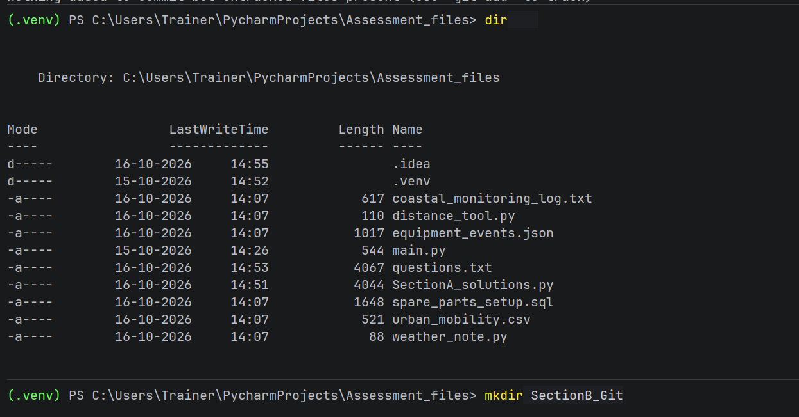
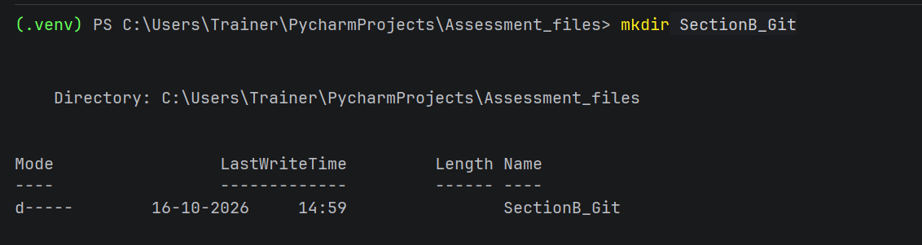
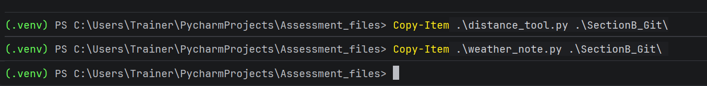
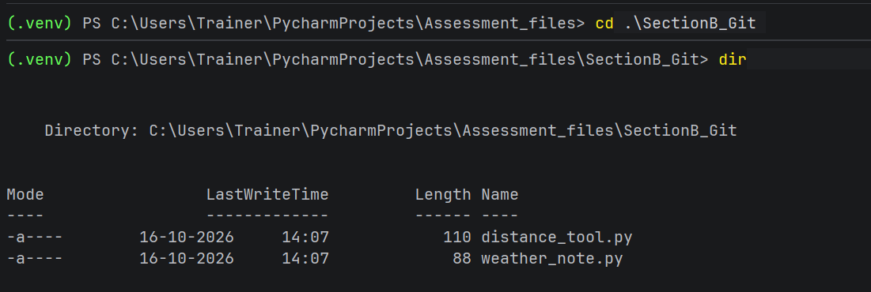
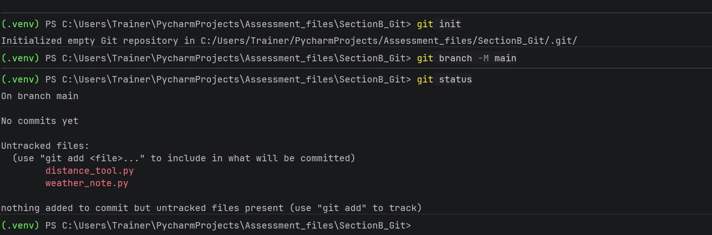
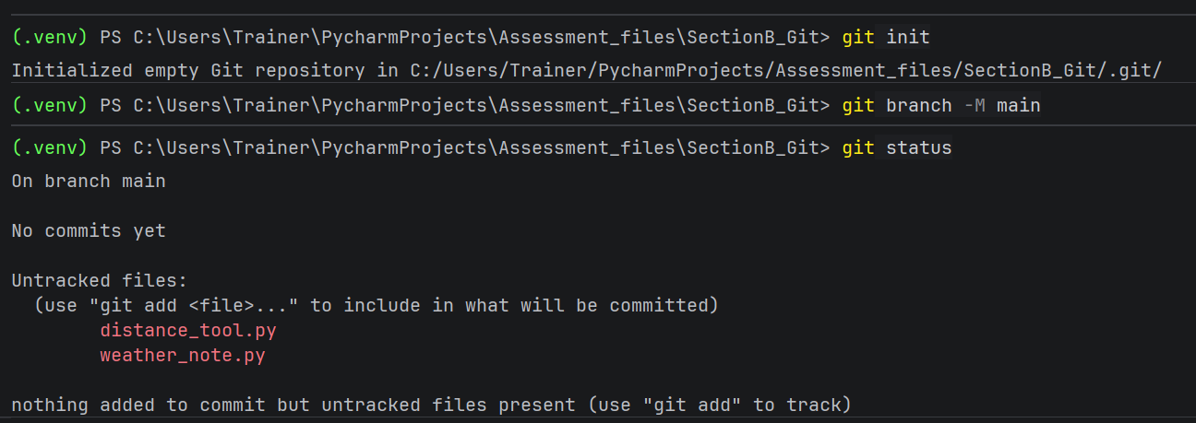
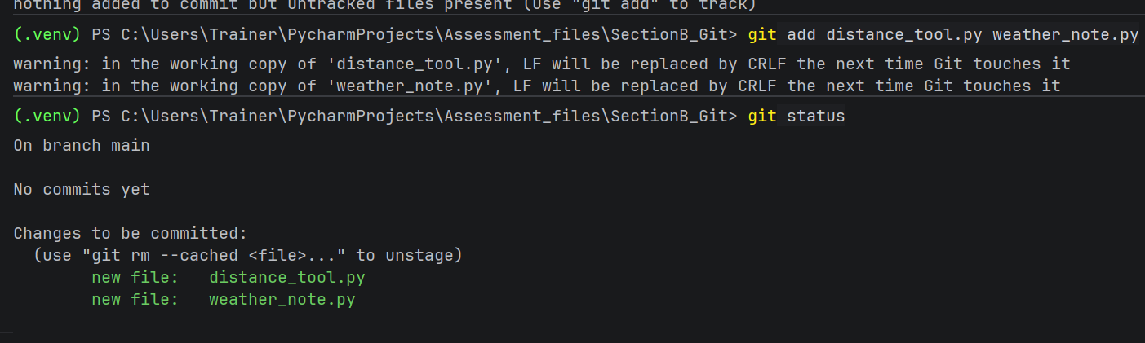
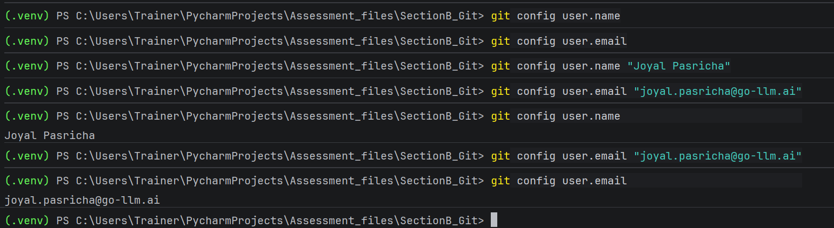

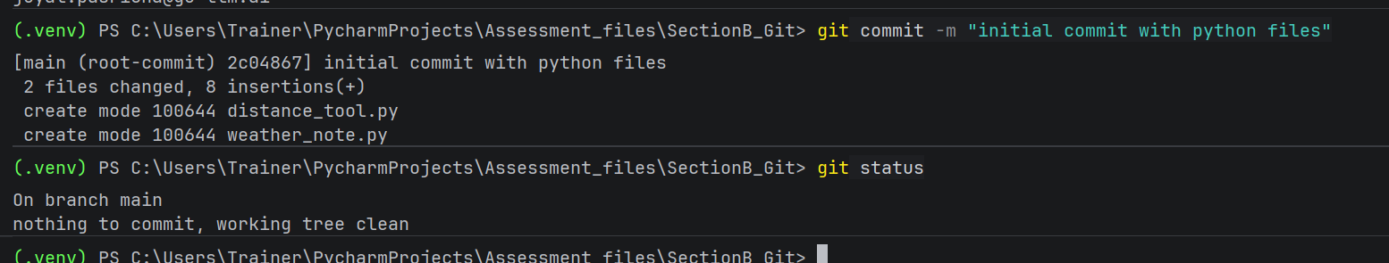
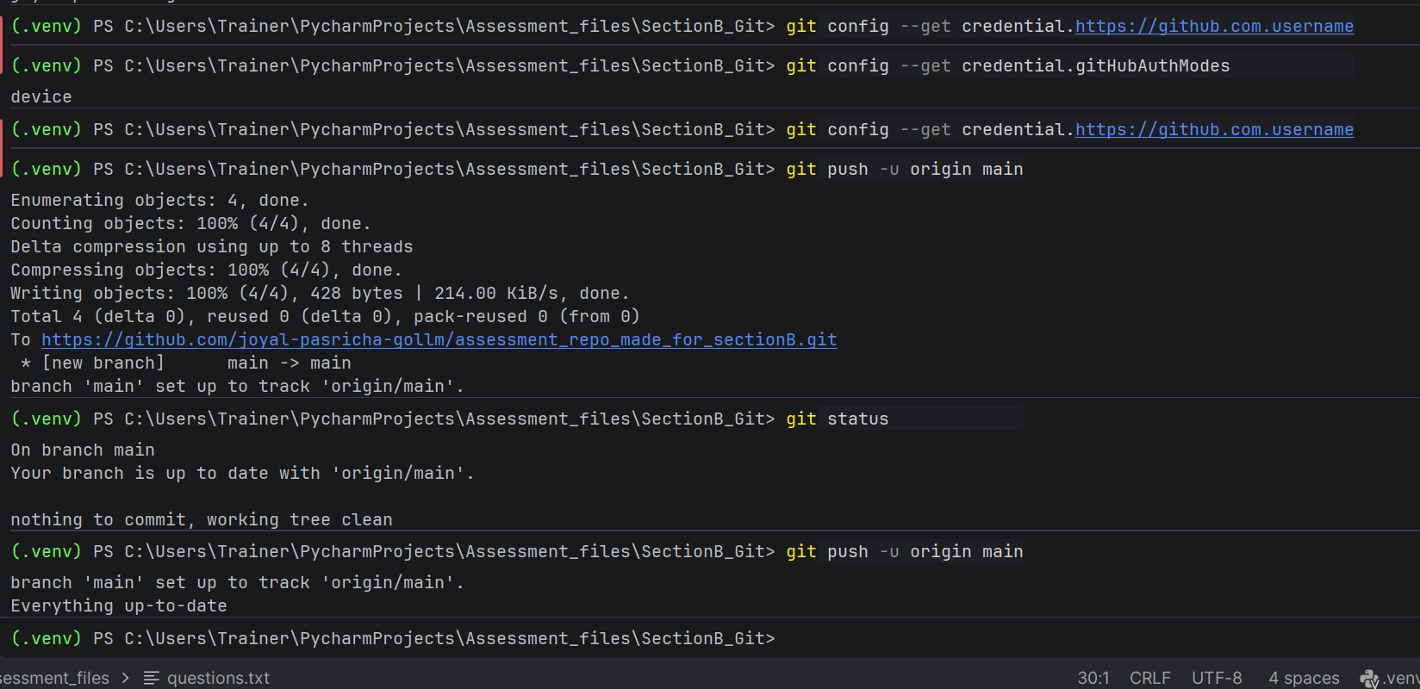
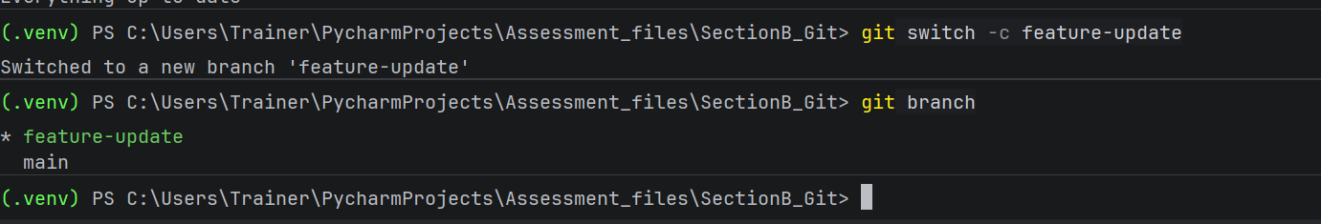
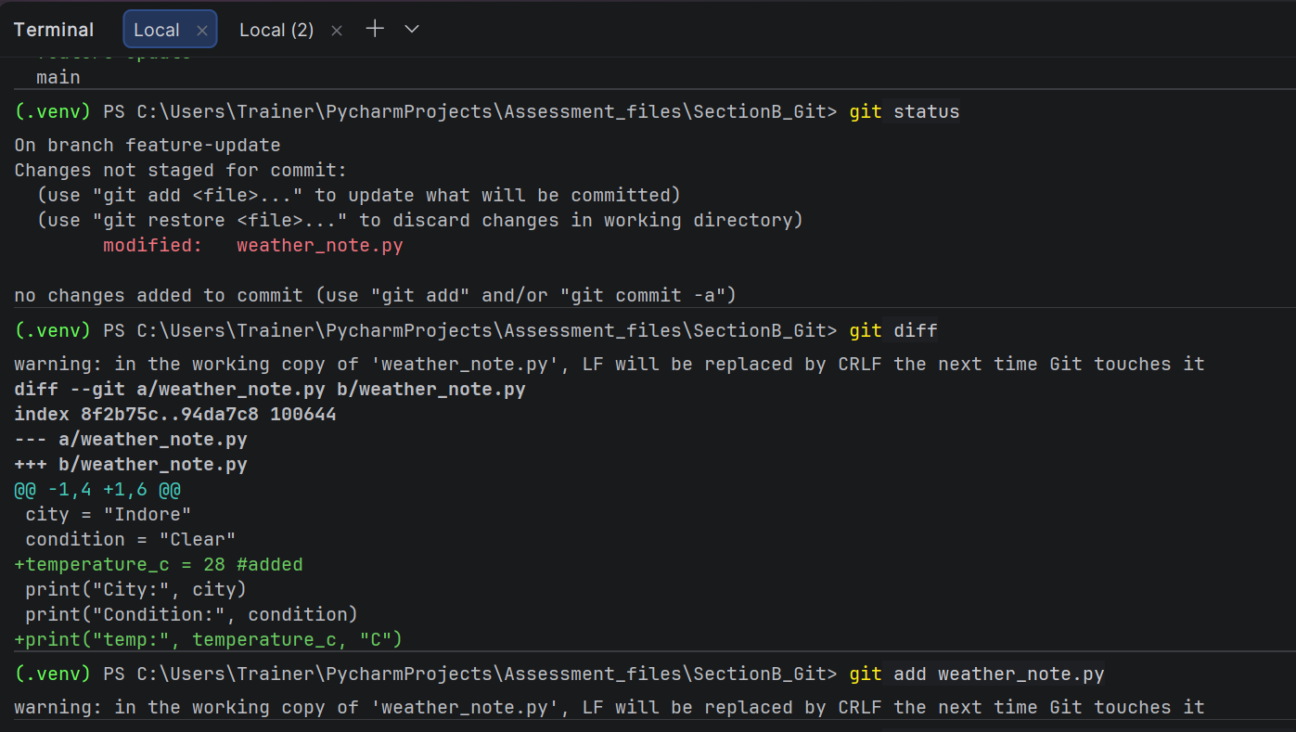
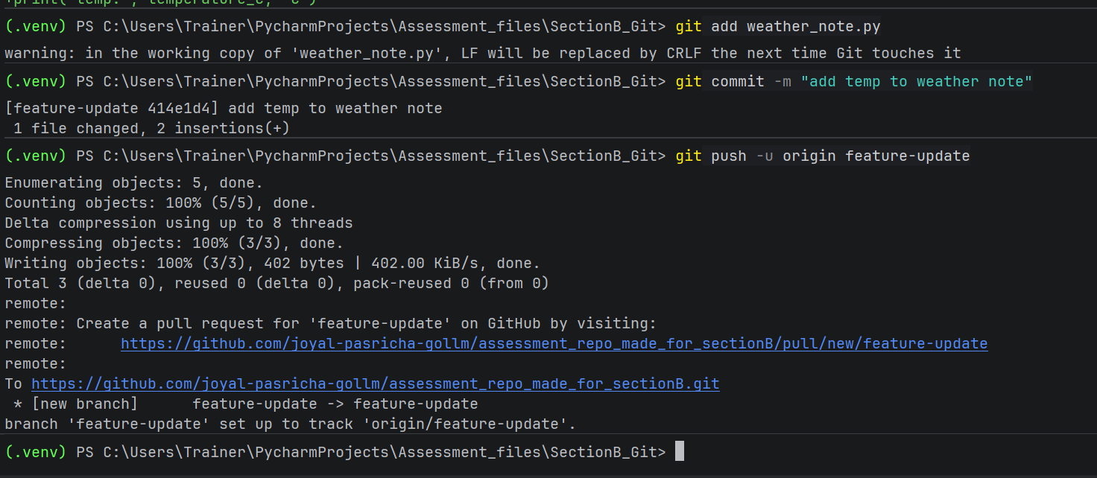
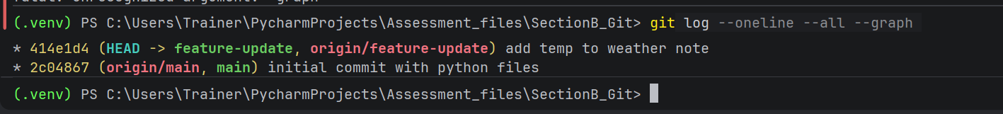
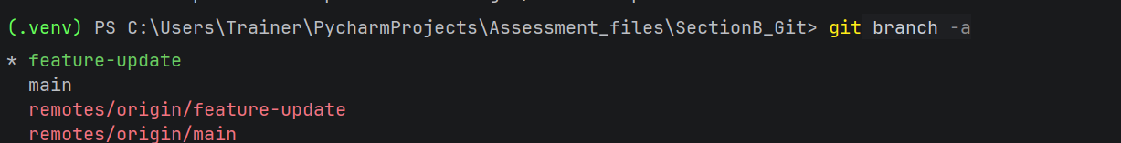
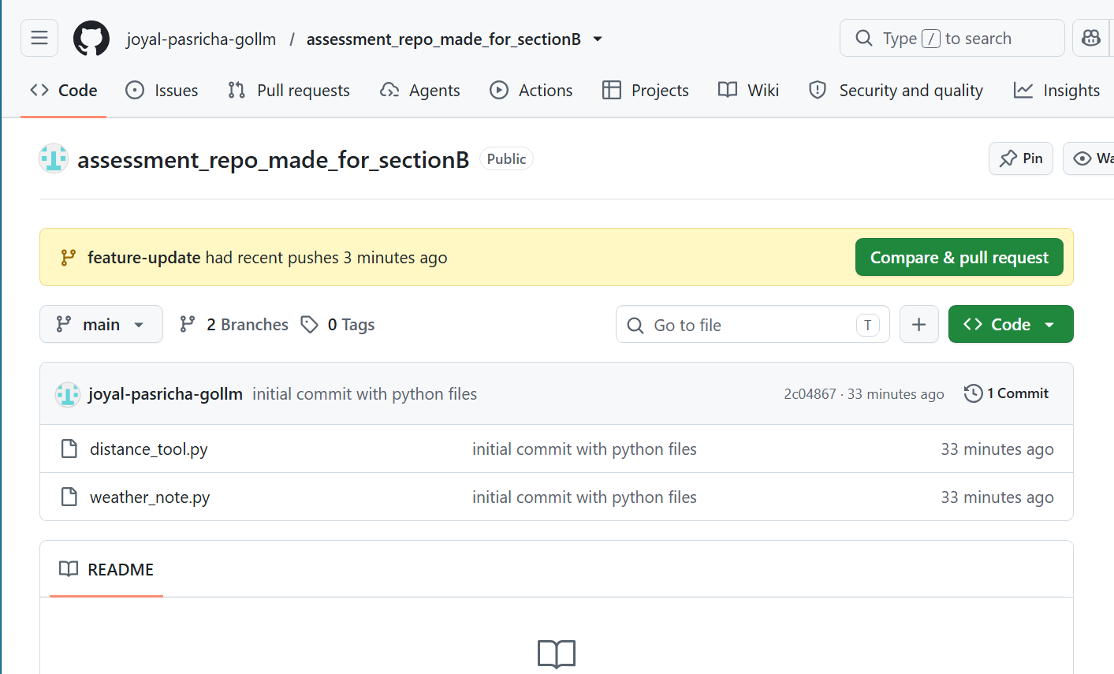
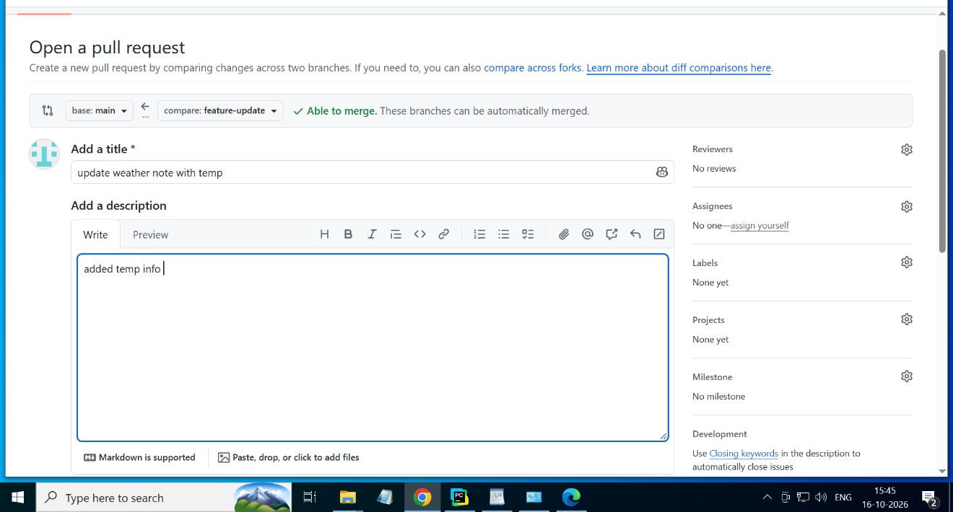

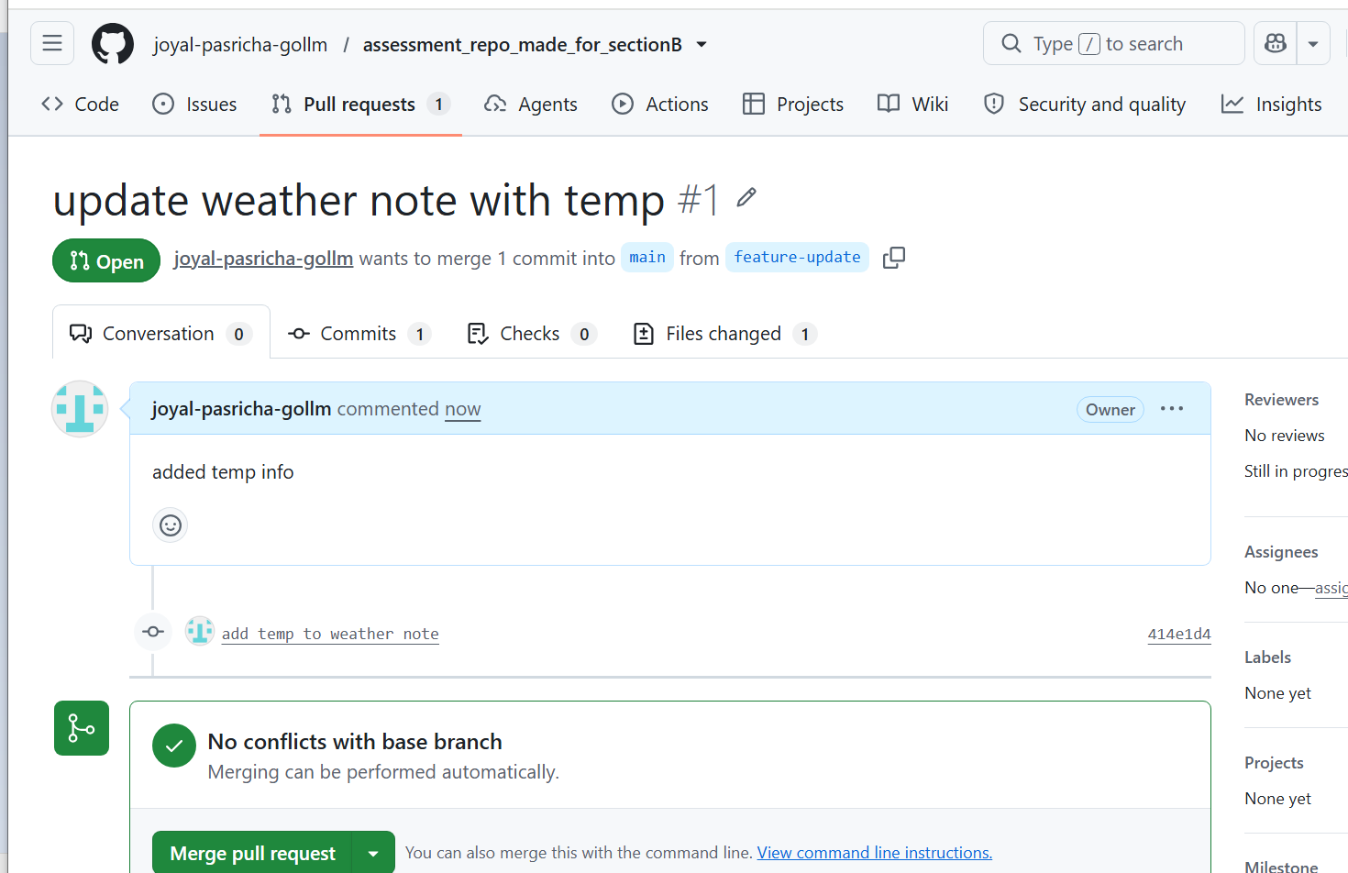
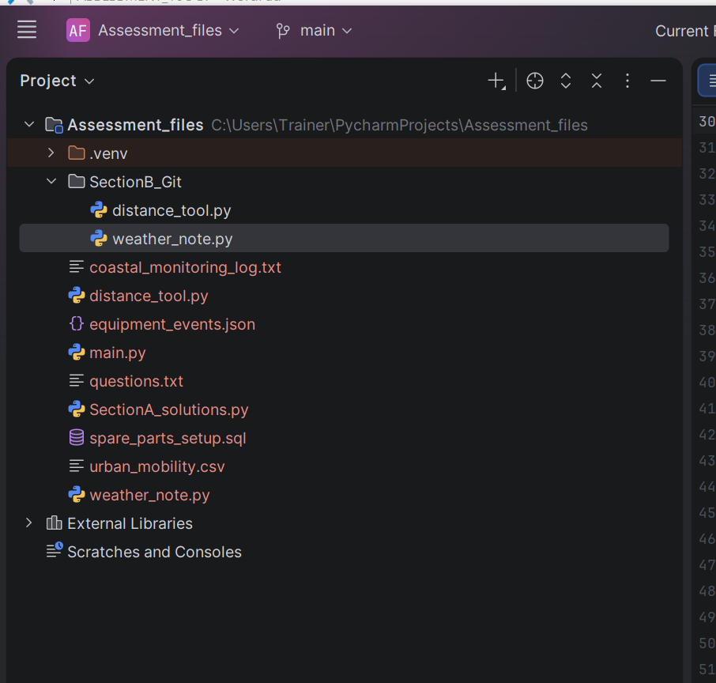

B5- Cloud vs On-premises
Cloud infrastructure uses computing resources provided over the internet by a cloud provider while on premises infrastructure uses hardware owned and maintained by the organisation. Cloud is generally easier to scale, while on premises requires the organisation to manage its own infrastructure.
B6- Azure subscription
It is a logical boundary used to organize azure resources and manage billing, quotas and usage.
B7- Azure resource group
It is a logical container used to organize and manage resources related to azure.
B8- correct heirarchy
subscription (1st)
resource group (2nd)
resource (3rd step)
B9-
Related azure resources may be placed in the same resource group because they can be managed,secured, monitored and cost-tracke dtogether and often share the same lifecycle.

SECTION C- answered the theory question in sql file as comments

